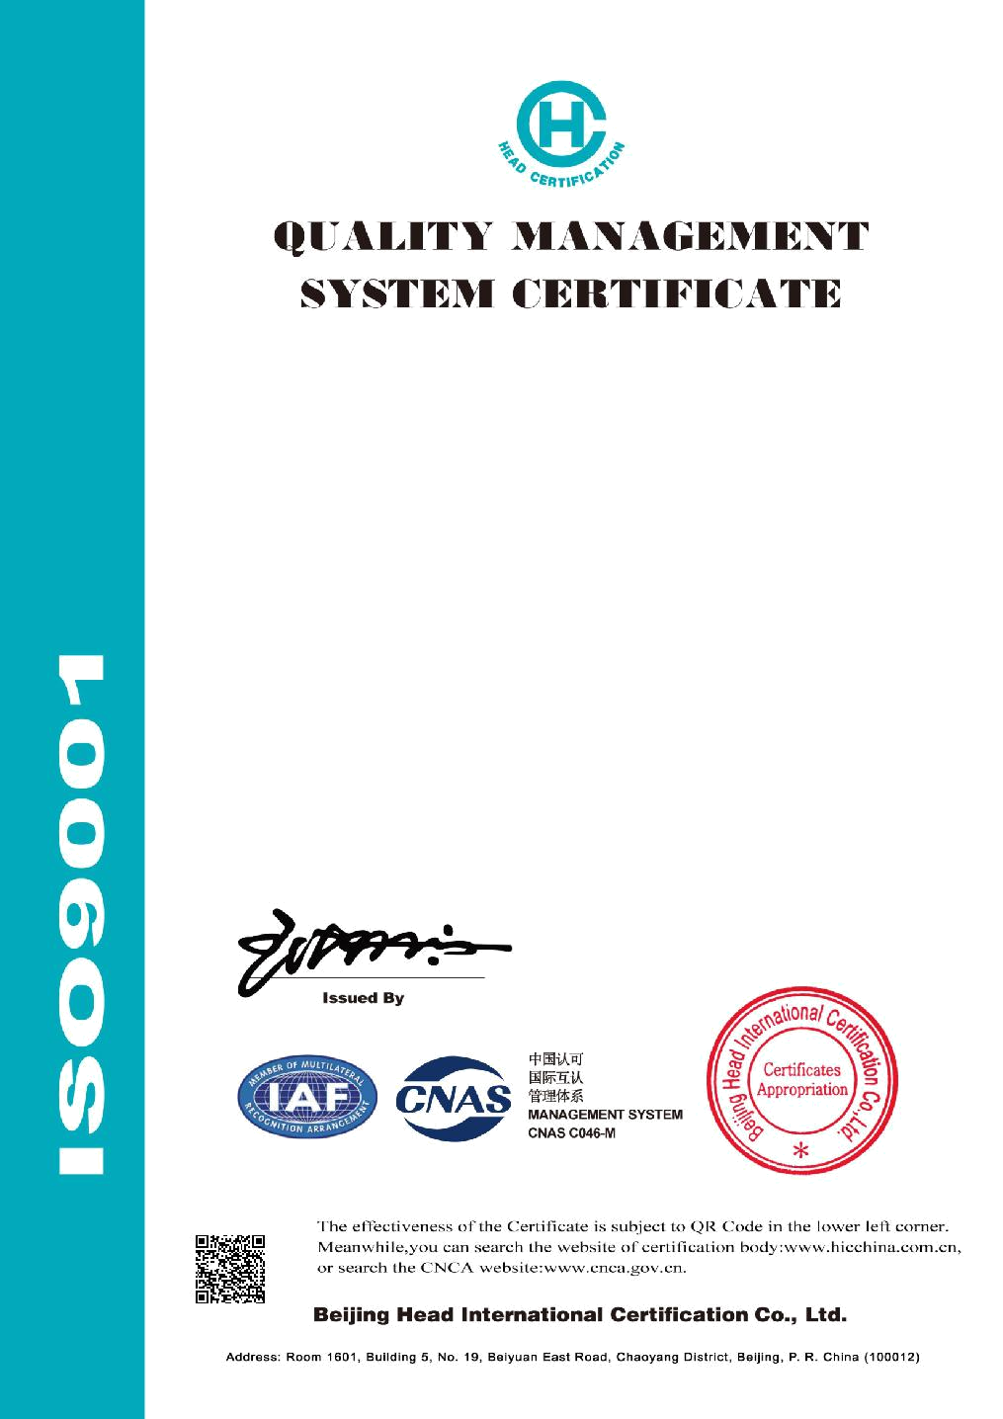

Certificate No.：04618Q13739R0S

We hereby certify that the organization:
Hunan Venice New Material
Technology Co., Ltd.

Unified social credit code: 91430100MA4L2NLT83

is in conformity with Quality Management System Standard:

GB/T19001-2016 / ISO9001:2015

The certificate is valid to the following product(s)/service:

Production of Removable Industrial Insulation Jackets and Removable Insulation Covers for Exhaust Pipe

Registration Address: West of Second Crossing, 101, Quadruple Workshop, No. 166, Guyuan Road, Changsha High-tech Development Zone, Changsha City, Hunan Province, P. R. China Physical Address: West of Second Crossing, 101, Quadruple Workshop, No. 166,

Guyuan Road, Changsha High-tech Development Zone, Changsha City, Hunan Province, P. R. China (Office Address); No. 2302, Fenglin West Road, Yuelu District, Changsha City, Hunan Province, P. R. China (Production Address)

Date of Issue：2018-09-12

Date of Expiry：2021-09-11

